Sumama Rahim
F24BSCS039
Database systems Lab 07 Task Report

Name | Sumama Rahim | Course | Database Systems (CSC-103) | Dprtt/ Program | IET - BSCS
Registration | F24BSCS039 | Instructor | Dr. M. Bilal Shahnawaz | Date | 05/04/2025

Lab 07 Task Report

Problem: Write a report to show the applied queries and their responses.

Solution:
Query: The total salary department wise.
-- The total salary department wise. --
SELECT Department, SUM(Salary) AS 'Total Salary'
fROM Faculty
GROUP BY Department;
Response:
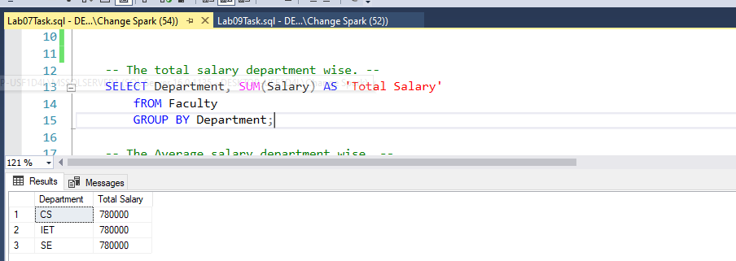
Query: The Average salary department wise.
-- The Average salary department wise. --
SELECT Department, AVG(Salary)
FROM Faculty
GROUP BY Department;
Response:
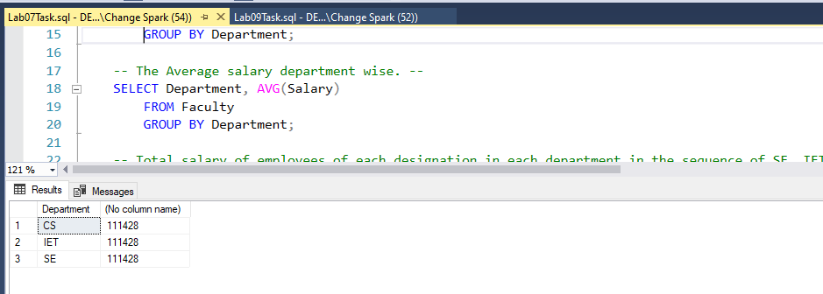

Query: Total salary of employees of each designation in each department in the sequence of SE, IET, CS Department.

-- Total salary of employees of each designation in each department in the sequence of SE, IET, CS Department. --
SELECT Designation, Department, SUM(Salary) AS 'Total Salary'
FROM Faculty
GROUP BY Department, Designation
ORDER BY Department DESC;
Response:
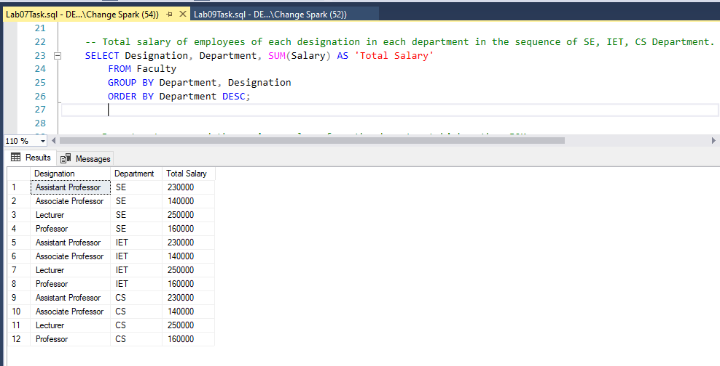

Query: Department name and the maximum salary from the department higher than 50K.
-- Department name and the maximum salary from the department higher than 50K. --
SELECT Department, MAX(Salary) AS 'MAX Salary'
FROM Faculty
GROUP BY Department
HAVING MAX(Salary) > 50000;
Response:
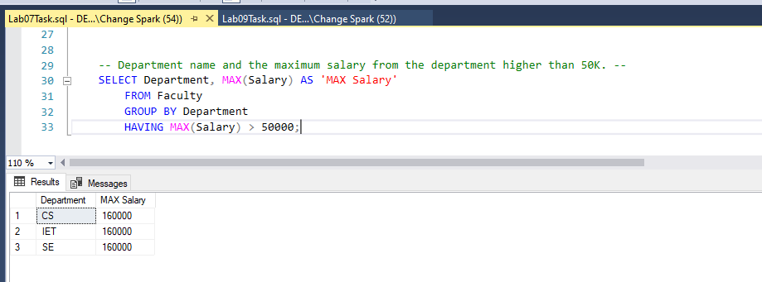

THE END

